**Grammar Homework**

* **Q (1):**

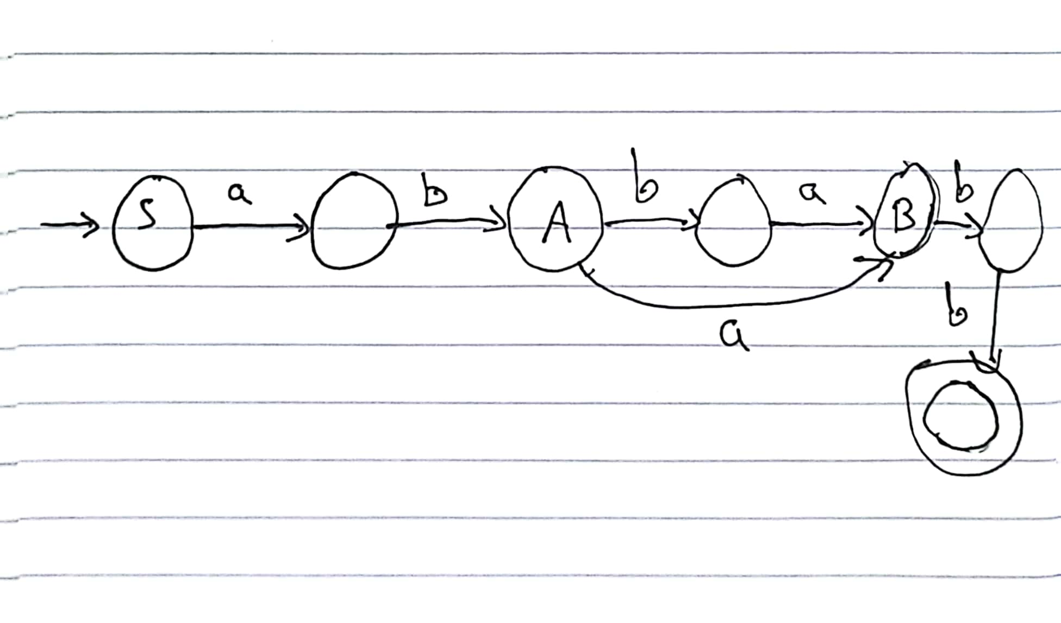

* **Q (4):** 
  + **Right linear:**

S → aaA

A → aA | B

B → bbbC

C → bC | λ

* + **Left linear:**

S → Abbb

A → Ab | B

B → Caa

C → Ca | λ

* **Q (5):**

**S** → aA | λ

**A**→ aB | bA | λ

**B** → aC | λ

**C** → bD

**D** → aC | bF

**F** → aF | bF | λ

* **Q (7):**

S → bS | aA| λ

A → bA | aB | λ

B → bB | aC | λ

C → bC | λ

* **Q (13):**
  + **A)** q0 → aq1 | bq2 | λ

q1 → bq3 | aq0

q2→ aq3 | bq0  
 q3 → aq2 | bq1

* + **B)** S → aA | bB

A → aB | bS | λ

B → aS | bA

* + **C)** S → aA| bB

A → aB| bS | a | b

B → aS | bA | a | b

* + **D)** S → aA | bB

A→ aB | bS | λ

B → aS | bA | λ

* + **E)** S → aA | bB

A → aS | bB

B → bS | aA

* **Q (16):**

S → A. B

A → 0 | 1 | 2 | … | 9

B → 0 | 1 | 2 | ... | 9

**Name: Yazan Amro**

**Student NO: 21920106**